**HOTEL REVENUE ANALYSIS**

**MODULE 2**

**1. Objective**

The goal of this module is to break down summary booking data into a daily level granular format. This allows for the analysis of daily revenue trends, occupancy rates per specific date, and the calculation of daily KPIs.

**2. Creation of Excel Tables:**

**2.1 Creation of Duration_Details Table:**

* We start with the Bookings Table containing the details of each booking.
* From Bookings Table, Create a table with columns: BookingID, DateID, RoomID, CustomerID, CheckInDate, CheckOutDate, NightsStayed, Total Price.
* Rename the table as Duration_Details.

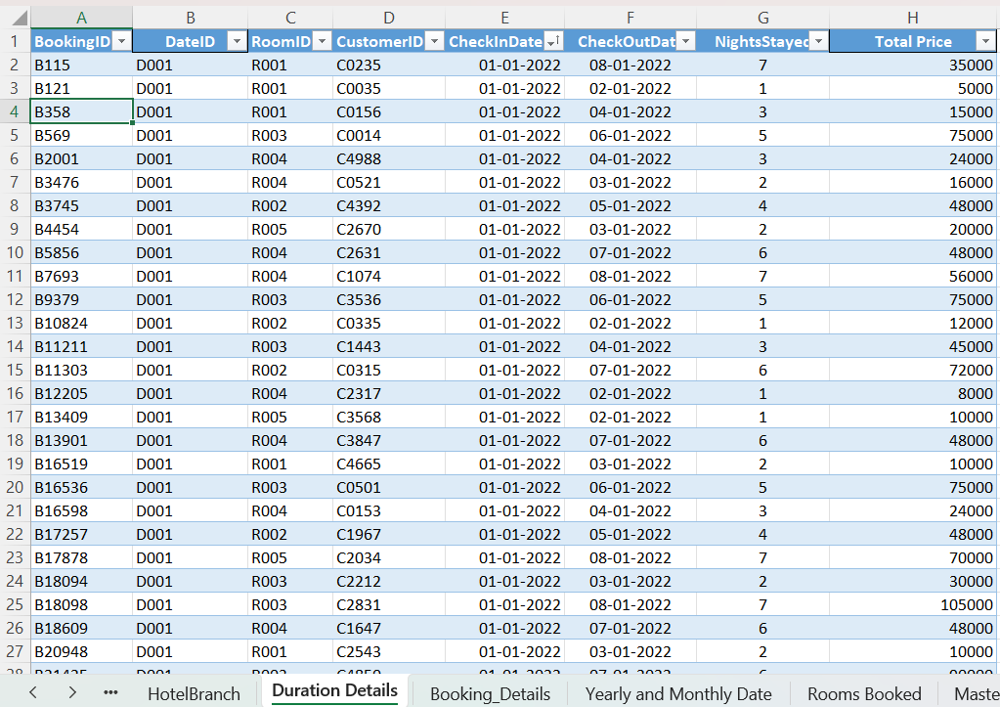

* Select the table.
* Go to Data Tab $→$  Get & Transform Data $→$  From Table/Range.

**2.1.1 Add Custom Column**

* In Power Query Editor, go to Add Column →Custom Column.
* New Column Name: StayDate
* Formula (M-Code):

if [CheckInDate] <> null and [CheckOutDate] <> null then

List.Dates(Date.From([CheckInDate]), Duration.Days([CheckOutDate] - [CheckInDate]), #duration(1,0,0,0))

else

null

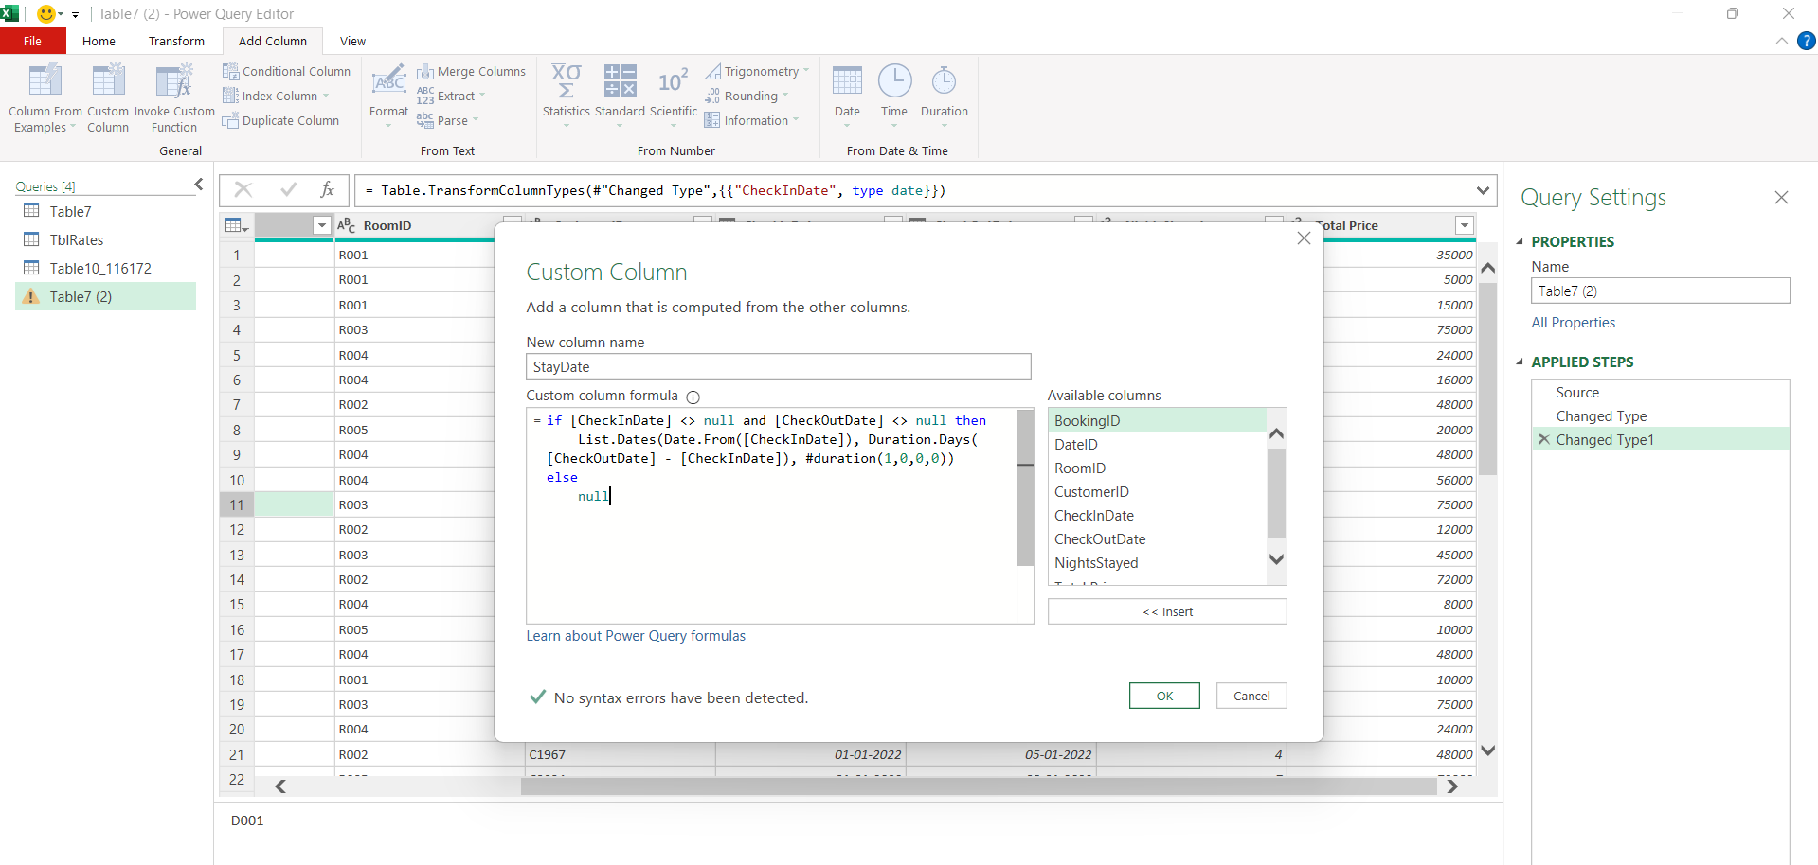

**2.1.2 Expand Rows:**

* Click the **Expand arrows** (two diverging arrows) next to the new StayDate column header.
* Select **"Expand to New Rows"**.
* *Result:* Each booking is now duplicated for every day the guest stayed.

**2.1.3** **Group By (Occupancy Count):**

* + Go to the **Transform** tab $→$ **Group By**.
  + **Group By:** StayDate.
  + **New Column Name:** Room Booked.
  + 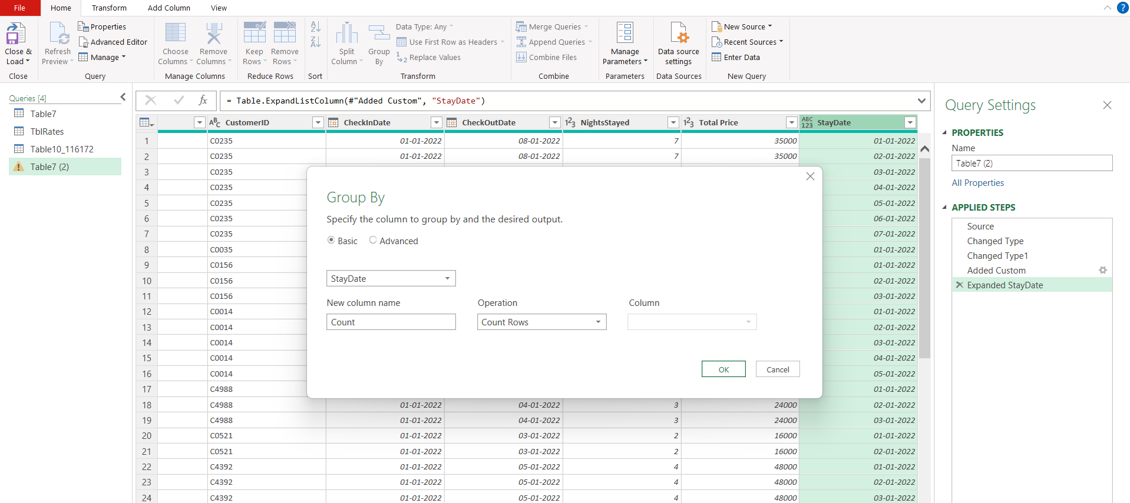**Operation:** Count Rows.

**2.1.4 Load Data:**

* + Go to Home $→$ Close & Load To...
  + Select New Worksheet.
  + Rename the worksheet to "**Rooms Booked**".

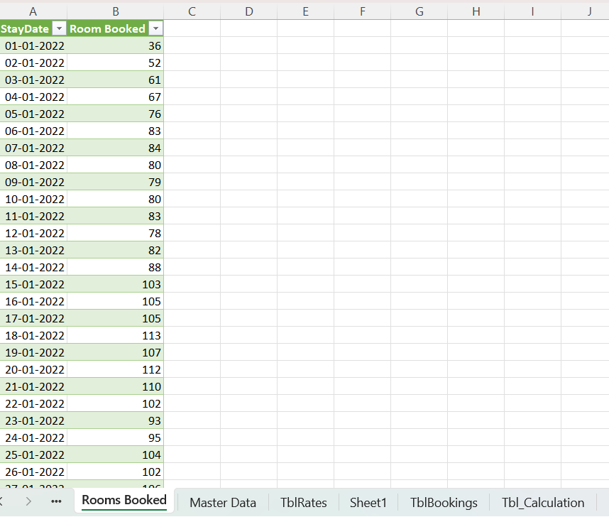

**2.2 Creating "Yearly and Monthly Date" (Pivot Table)**

This sheet is used for a quick summary view of room bookings aggregated by time.

1. Insert Pivot:
   * Click anywhere inside the "Rooms Booked" table created in Step 1.
   * Go to Insert $→$ PivotTable $→$ New Worksheet.
2. Configure Fields:
   * Rows: Drag Years, Months, and StayDate.
   * Values: Drag Room Booked (Ensure it is set to Sum).
3. Formatting:
   * Rename the worksheet to "Yearly and Monthly Date".

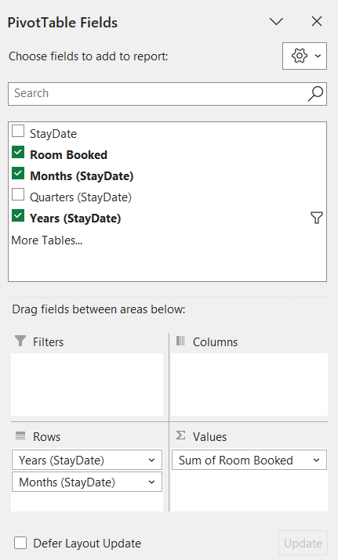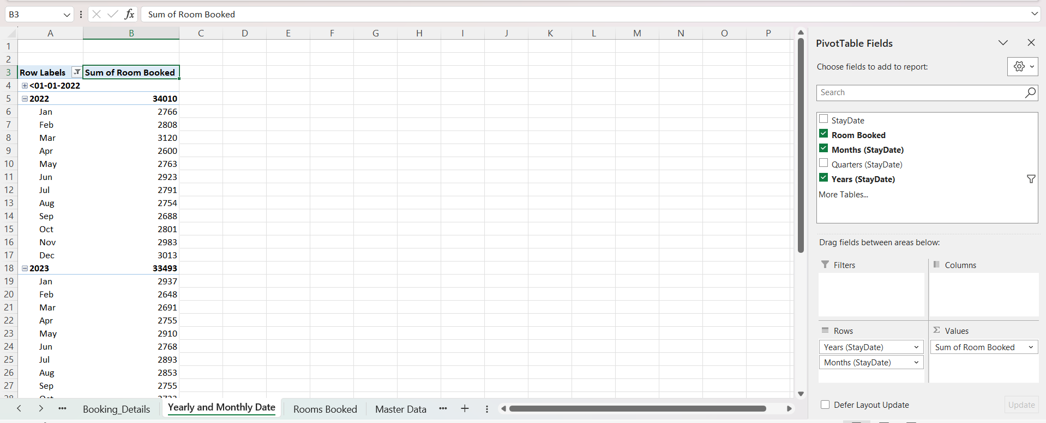

**2.3 Creating "Master Data" Table**

1. Create Table: Create a new sheet named "Master Data".
2. Columns & Formulas:

* Month: Enter Month Starts from 01-Jan-2022 to 31-Dec-2024.
* Day Count =DAY(EOMONTH(A2,0))
* Room Available =B2*150
* Rooms Sold: Take Data from Yearly and Monthly Date table.
* Occupancy Rate =(D2/C2)*100

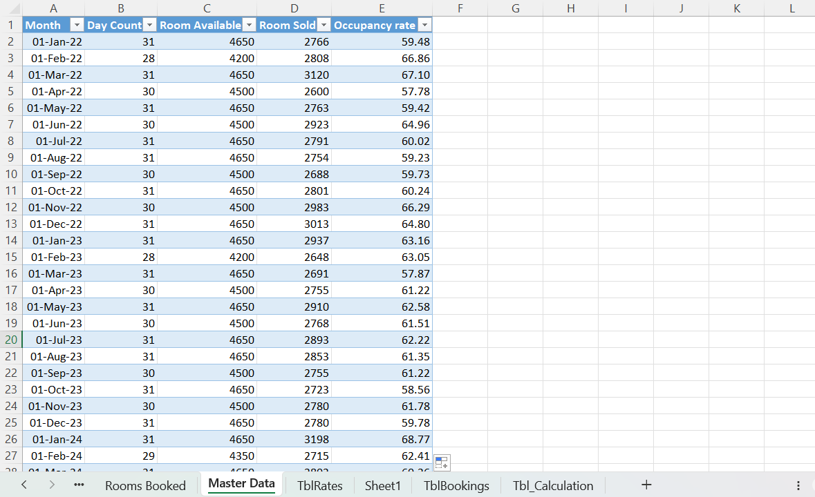

**2.4 Creating Booking_Details Table**

1. Create a new Sheet named “Booking_Details”.
2. Columns and Formulas:

* StayDate and Room Booked: Copy from Rooms Booked Table.
* Month Year =TEXT(A2, "mmm yyyy")
* Month Start =DATE(YEAR(A2), MONTH(A2), 1)
* Year =YEAR(A2)
* Month =MONTH(A2)
* Season

=IF(OR(MONTH(A2)=12,MONTH(A2)<=2),"Winter",

IF(MONTH(A2)<=5,"Spring",

IF(MONTH(A2)<=8,"Summer","Autumn")))

* Weekday =TEXT(A2,"dddd")
* WeekNum =WEEKNUM(A2,1)
* WeekStart =A2-WEEKDAY(A2)+1
* YearWeek=YEAR(A1+3-WEEKDAY(A1,3)) & "-W" & TEXT(ISOWEEKNUM(A1), "00")

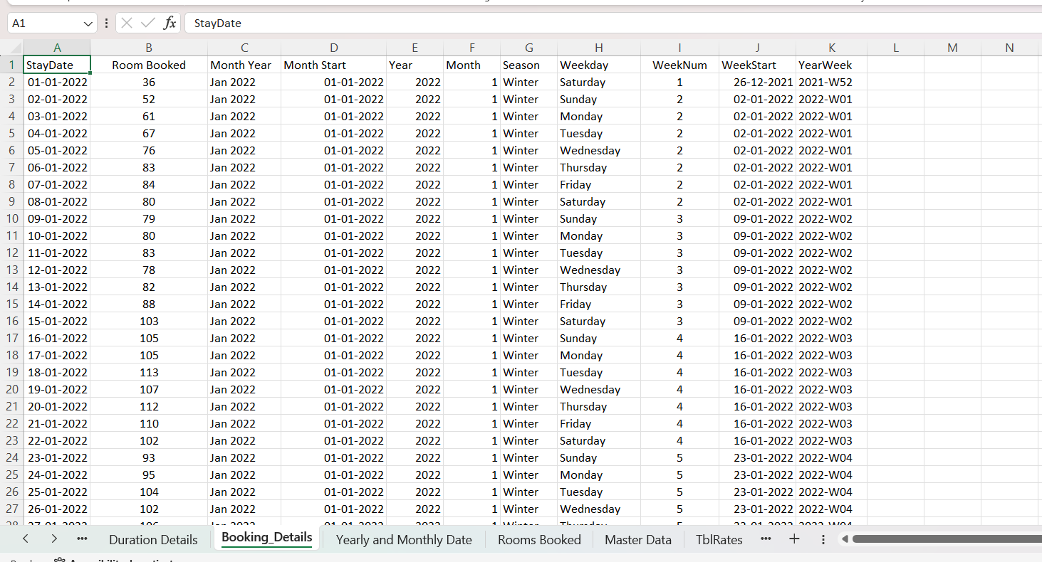

**2.5 Creating TblRates Table**

Create a new sheet named TblRates with a table containing RoomID and Price as columns

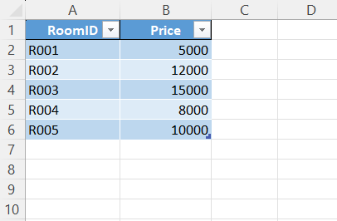

**2.6 Creating TblBookings Table**

* Create a new sheet.
* Create a Table with Columns BookingID, CustomerID, BranchID, RoomID, CheckInDate, CheckOutDate, NightsStayed, StayDate from Booking_Details Table
* Go to Data →Get Data →Combine Queries → Merge.

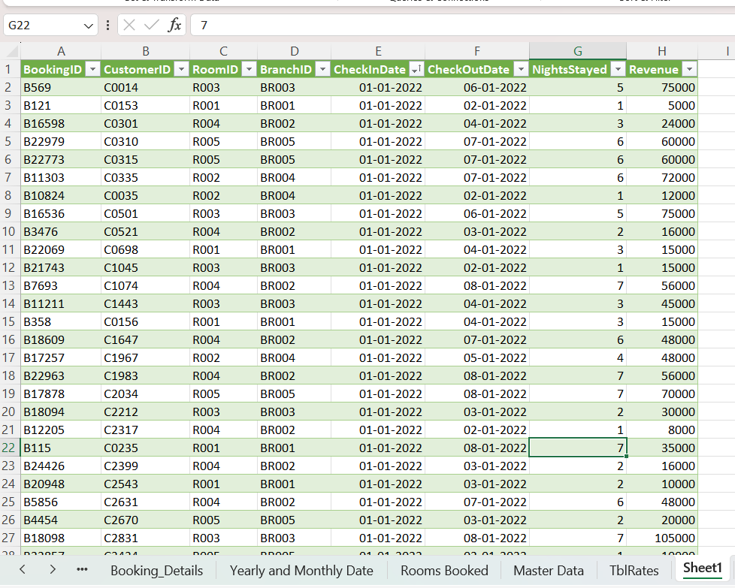

* Table 1: Table10_11672
* Table 2: TblRates.
* 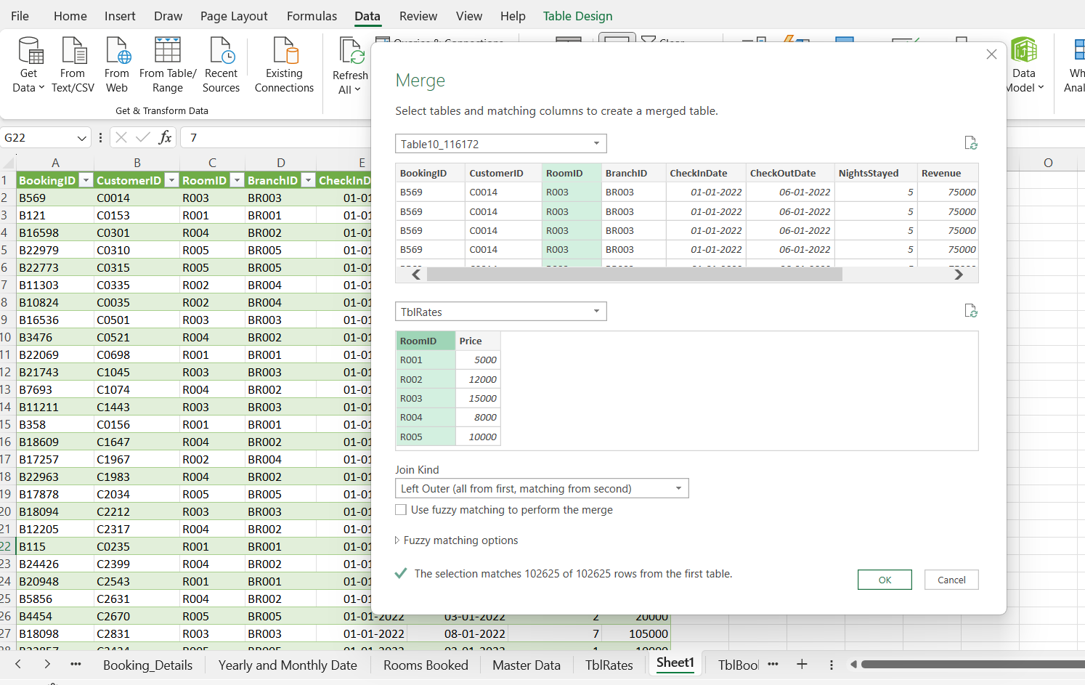Join Match: Select RoomID in both tables and click OK.
* In the Power Query Editor, click the expand icon on the merged TblRates column.
* Check **only** Price.
* Rename this column to **DayRevenue**.
* Close & Load To → New Table.
* 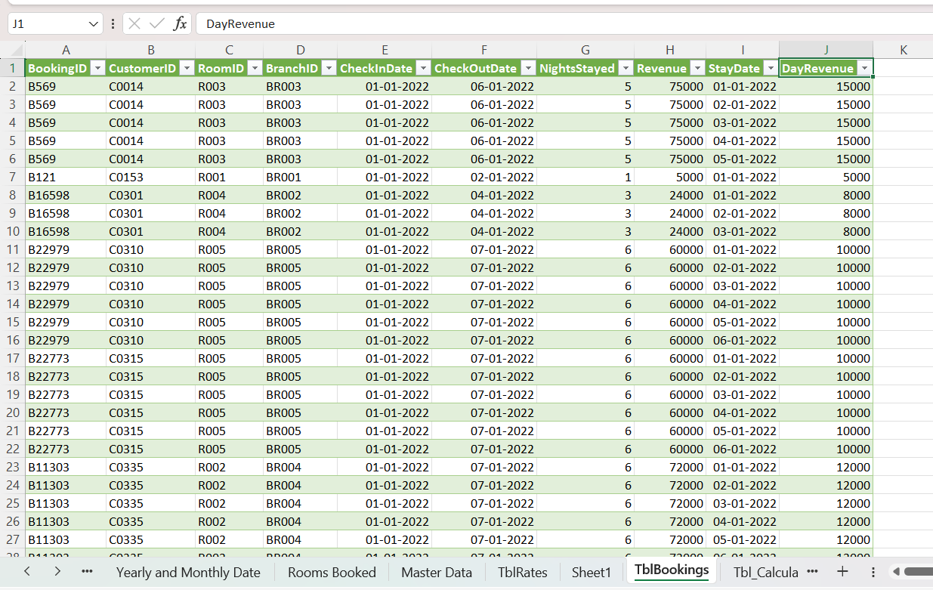Rename this sheet to "TblBookings".

**2.7 Creating "Tbl_Calculation" (Final KPI Table)**

This is the consolidated table used for final calculations using the derived data.

1. **Create Sheet:** Name it **"Tbl_Calculation"**.
2. **Columns & Formulas:**

* StayDate and Room Booked Count : Copy from Rooms Booked Table.
* Total Revenue =SUMIFS(TblBookings!J:J, TblBookings!I:I, Tbl_Calculation!A2)
* Total Rooms = 150
* Occupancy % =B2/D2*100
* ADR =C2/B2 (DataType : Currency -> English (India))
* RevPAR =(F2 * E2)/100
* Season

=IF(OR(MONTH(A2)=12,MONTH(A2)<=2),"Winter",

IF(MONTH(A2)<=5,"Spring",

IF(MONTH(A2)<=8,"Summer","Autumn")))

* Weekday =TEXT(A2,"dddd")
* Week =WEEKNUM(A2)
* MonthStart =DATE(YEAR(A2), MONTH(A2), 1)
* Month =TEXT(A2,"MMMM")
* Quarter ="Q" & ROUNDUP(MONTH(A2)/3, 0)

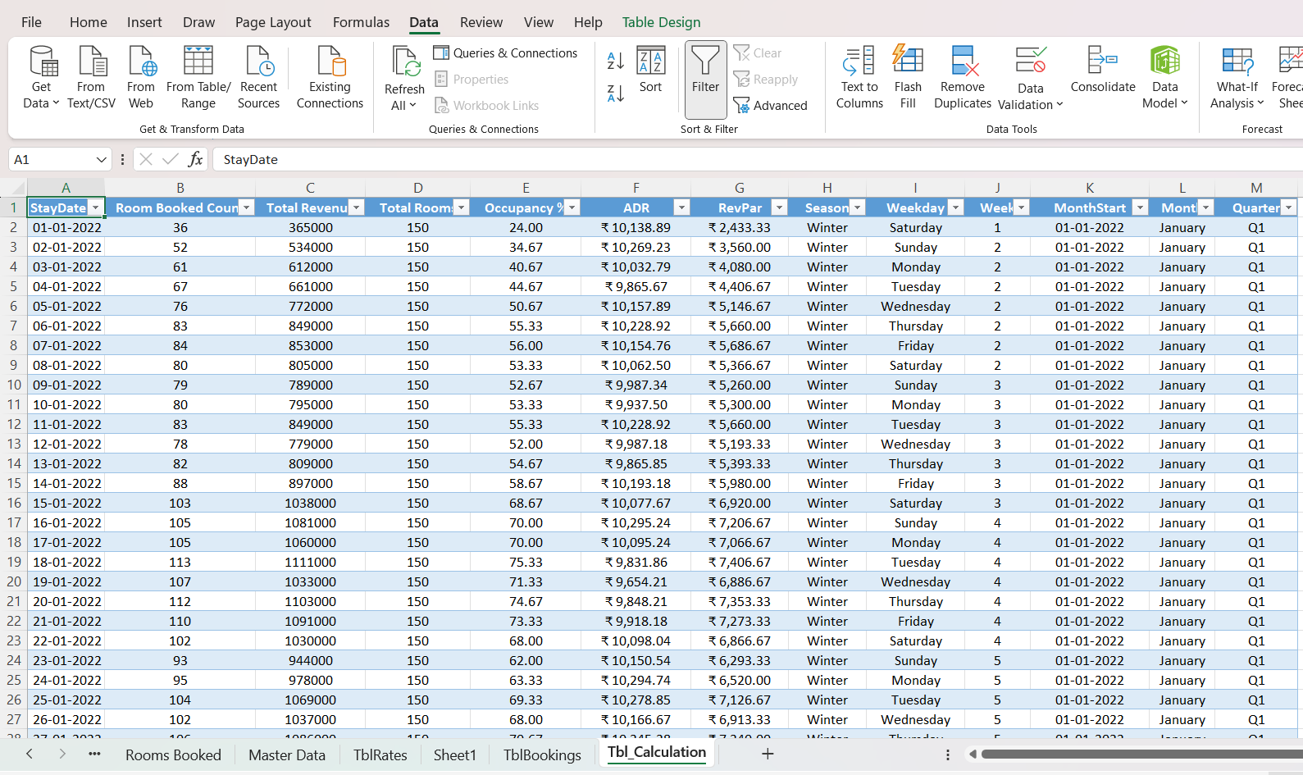

1. **Power BI Data Modelling**

**3.1 Importing Data to Power BI**

Open Power BI Desktop.

* Click on Home →Get Data →Excel Workbook.
* Select the file containing your prepared tables (Booking_Details, Rooms Booked, TblRates, TblBookings, Tbl_Calculation).
* In the Navigator, select the following tables:

Booking_Details, Rooms Booked, TblRates, TblBookings, Tbl_Calculation

* Click Load.

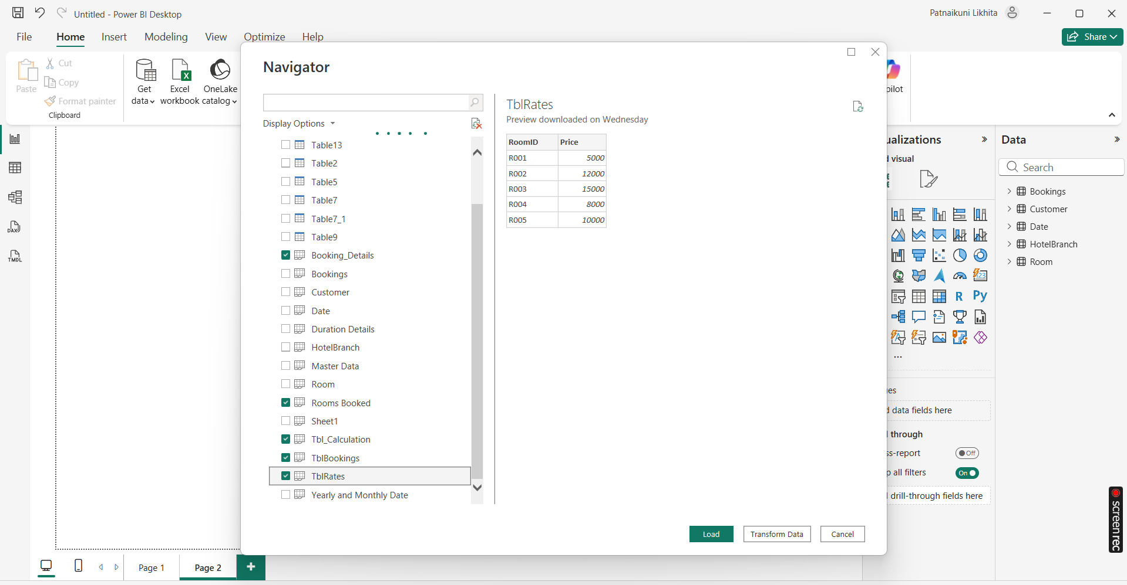**3.2** **Enhancing Booking_Details (Calculated Columns)**

1. Go to the Data View (Table icon on the left).
2. Select the Booking_Details table.
3. Click New Column
4. Formula:

MonthStart = DATE(YEAR([StayDate]), MONTH([StayDate]), 1)

1. Create Columns in the same process for:

* MonthYear = FORMAT([StayDate], "MMM YYYY")
* Year = YEAR([StayDate])
* Month = FORMAT([StayDate], "MMMM")
* Season = SWITCH( TRUE(), MONTH([StayDate]) IN {12,1,2}, "Winter",

MONTH([StayDate]) IN {3,4,5}, "Spring",

MONTH([StayDate]) IN {6,7,8}, "Summer",

MONTH([StayDate]) IN {9,10,11}, "Autumn" )

* Weekday = FORMAT([StayDate], "dddd")
* WeekNum = WEEKNUM([StayDate].[Date])
* WeekStart = [StayDate] - WEEKDAY([StayDate].[Date]) + 1
* YearWeek = VAR SundayOfWeek = [StayDate] - WEEKDAY([StayDate], 1) VAR ISOYear = YEAR(SundayOfWeek) VAR ISOWeek = WEEKNUM(SundayOfWeek, 1) RETURN ISOYear & "-W" & FORMAT(ISOWeek, "00")

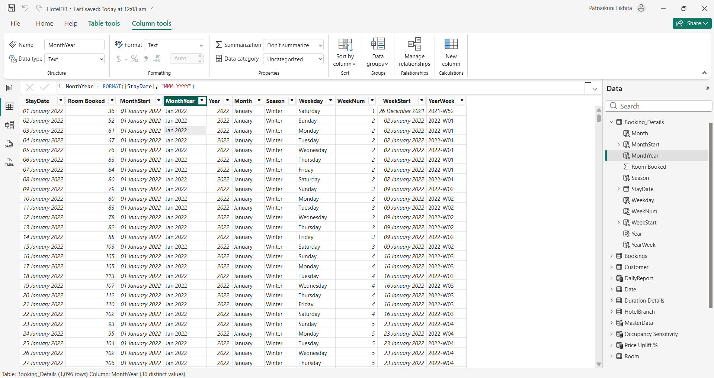

**3**.**3 Creating the MasterData Table (DAX Calculated Table)**

1. Go to the **Modeling** tab $→$  click **New Table**.
2. Paste the following DAX formula:

MasterData =

VAR CalendarTable =

    ADDCOLUMNS (

        CALENDAR (DATE(2022,1,1), DATE(2024,12,31)),

        "MonthStart", EOMONTH([Date], -1) + 1,

        "Month", FORMAT(EOMONTH([Date], -1) + 1, "dd-mmm-yy"),

        "DayCount", DAY(EOMONTH([Date], 0)),

        "RoomAvailableCount", DAY(EOMONTH([Date], 0)) * 150

    )

RETURN

    ADDCOLUMNS (

        SUMMARIZE (

            CalendarTable,

            [MonthStart], [Month], [DayCount], [RoomAvailableCount]

        ),

        "RoomSoldCount",

            CALCULATE (

                SUM (Booking_Details[Room Booked]),

                TREATAS ( { [MonthStart] }, Booking_Details[MonthStart] )

            ),

        "Occupancy %",

            DIVIDE (

                CALCULATE (

                    SUM (Booking_Details[Room Booked]),

                    TREATAS ( { [MonthStart] }, Booking_Details[MonthStart] )

                ),

                [RoomAvailableCount],

                0

            ) * 100

    )

1. Right-click on the **MasterData** table and select New Column
2. Formula:

**TotalRevenue** = CALCULATE(

SUM(Bookings[Revenue]),

    FILTER(Bookings, Bookings[MonthStart] = MasterData[MonthStart])

)

Total Revenue represents the gross income generated strictly from room bookings for the selected month.

1. Again, Click on New Column
2. Formula:

**ADR** = DIVIDE(

    [TotalRevenue],

    MasterData[RoomSoldCount]

)

**Average Daily Rate (ADR)** represents the average price paid for an **occupied** room.

* + **Formula:** Total Revenue / Total Rooms Sold
  + **Insight:** Tells you how expensive your rooms are.
    - *Scenario:* If Revenue is high but ADR is low, you are selling many cheap rooms (Volume strategy).
    - *Scenario:* If ADR is high, you are selling premium rooms.

1. Click on New Column
2. Formula:

**RevPAR** = [ADR] * DIVIDE(MasterData[Occupancy %], 100)

**RevPar** represents the revenue generated per room in the hotel, regardless of whether it was occupied or empty.

* + **Formula:** ADR * Occupancy %
  + **Insight:** This is the most important metric**.** It balances price and occupancy.
    - *Why?* A hotel selling 1 room for $1000 (High ADR, Low Occupancy) might make less money than a hotel selling 100 rooms for $50 (Low ADR, High Occupancy). RevPAR reveals the true efficiency.

1. Click on New Measure and create the following measures:

**DAX MEASURES:**

* + **MADR** =

DIVIDE(

SUM(Bookings[Revenue]),

SUM(Bookings[RoomNightsSold]))

* + **MRevPAR** =

DIVIDE(

SUM(Bookings[Revenue]),

SUM(MasterData[RoomAvailableCount]))

* + **MOccupancy %** =

DIVIDE(

SUM(Bookings[RoomNightsSold]),

SUM(MasterData[RoomAvailableCount]),

0

) * 100

* + **MonthlyADR** =

CALCULATE(

[MADR],

ALLEXCEPT(MasterData, MasterData[MonthStart])

)

* + **MRevPAR =**

DIVIDE(

SUM(Bookings[Revenue]),

SUM(MasterData[RoomAvailableCount]))

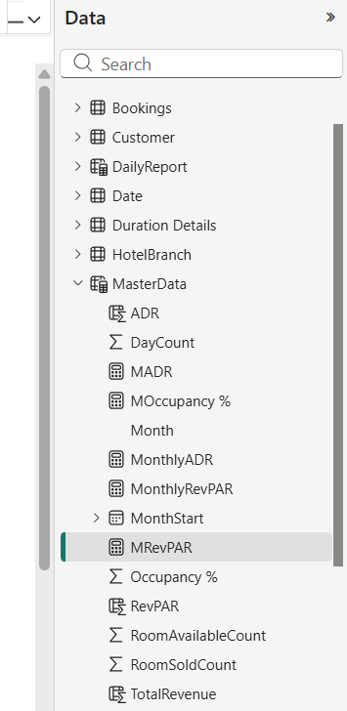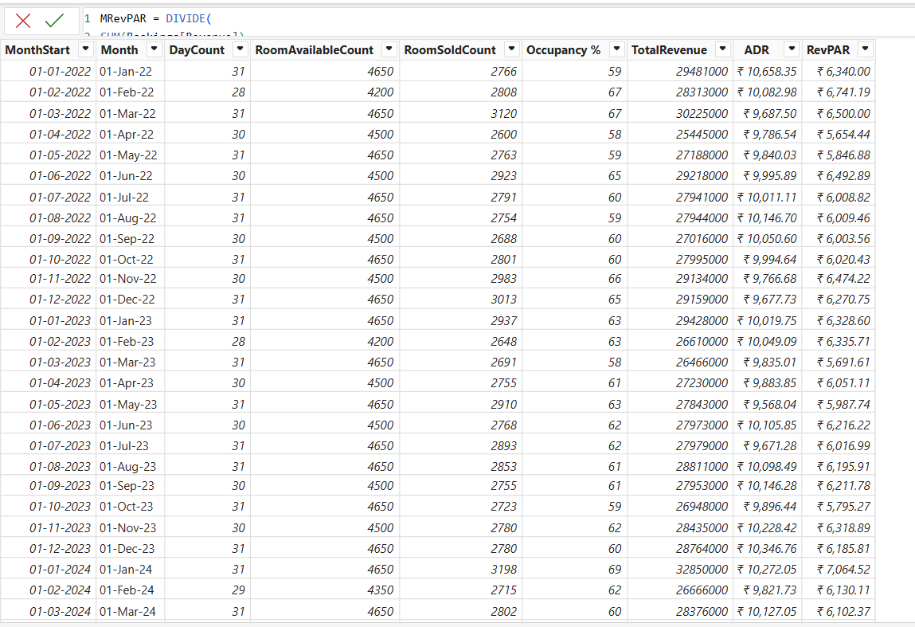

**3.4 Enhancing Tbl_Calculation table**

1. Go to the Modeling tab $→$  click New Measure.
2. Create the following measures:

ADR YY Change =

DIVIDE(

    [ADR] - CALCULATE([ADR], SAMEPERIODLASTYEAR('tbl_Calculation'[StayDate])),

    CALCULATE([ADR], SAMEPERIODLASTYEAR('tbl_Calculation'[StayDate].[Date]))

)

MWeek = WEEKNUM(SELECTEDVALUE(tbl_Calculation[StayDate]), 2)

Occupancy % Last Month = CALCULATE([MOccupancy %], PREVIOUSMONTH(tbl_Calculation[StayDate]))

RevPAR YY Change =

DIVIDE(

    [RevPAR] - CALCULATE([RevPAR], SAMEPERIODLASTYEAR(tbl_Calculation[StayDate])),

    CALCULATE([RevPAR], SAMEPERIODLASTYEAR(tbl_Calculation[StayDate]))

)

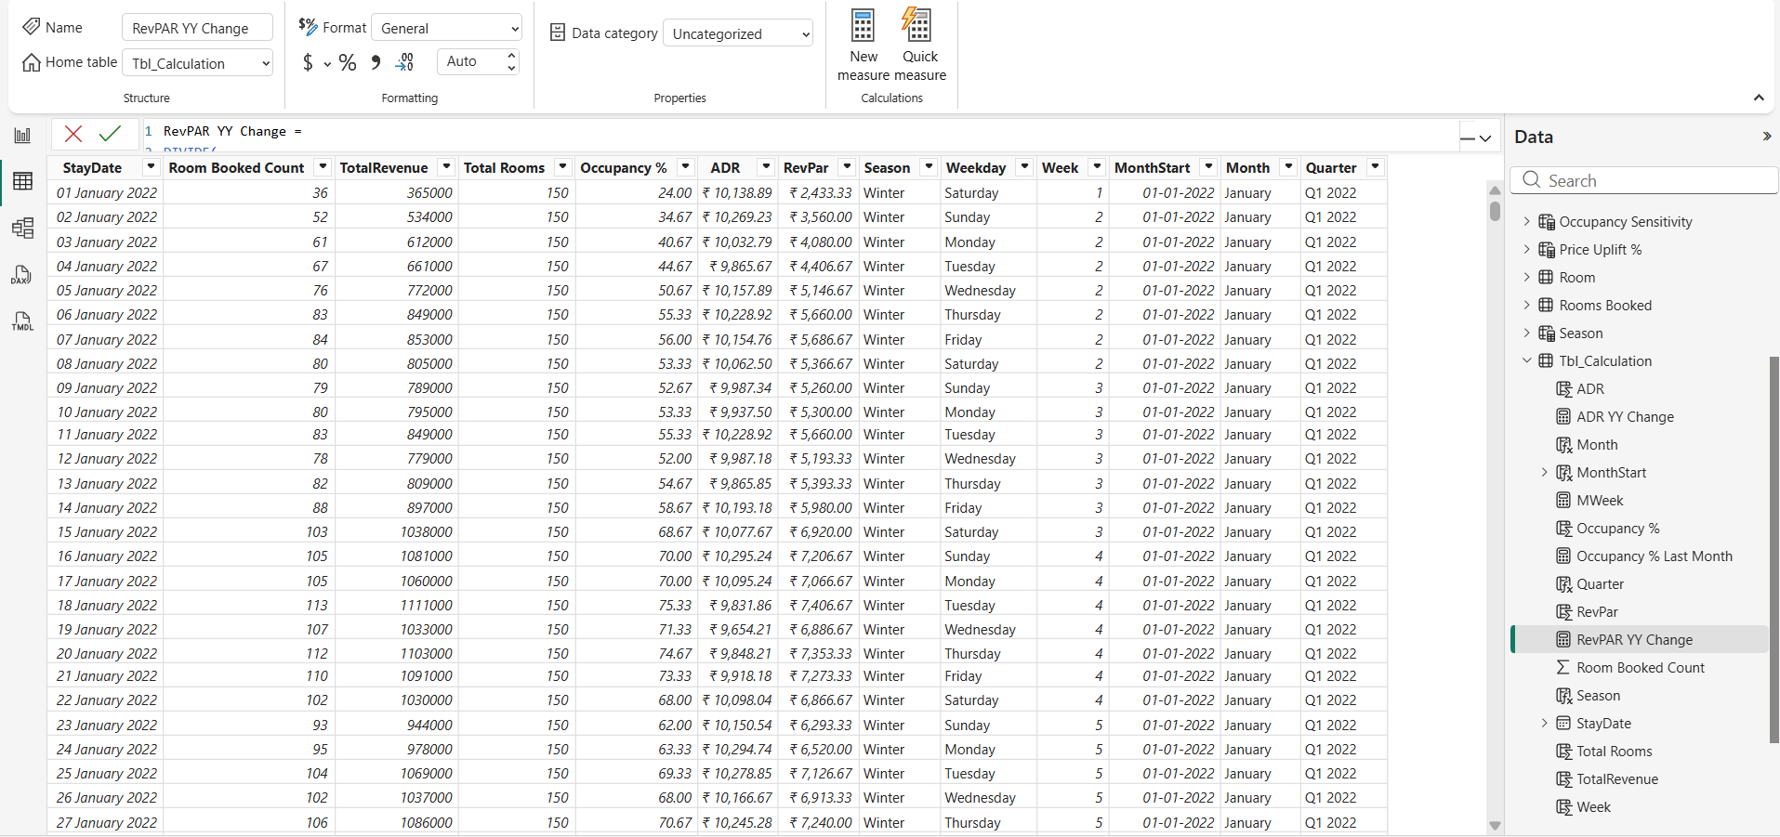

**3.5 Creation of Monthly Bookings Table**

1. Go to the Modeling tab $→$  click New Table.
2. Formula:

MonthlyBookings =

SUMMARIZE (

Booking_Details,

Booking_Details[MonthStart],

"TotalRoomsBooked", SUM(Booking_Details[Room Booked])

)

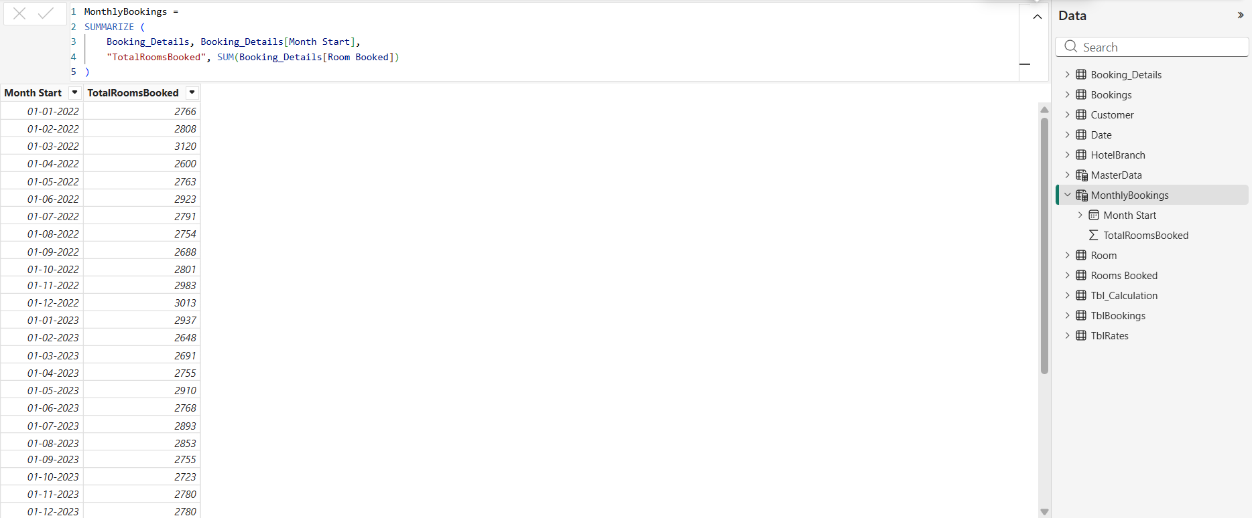

**4. PowerBI Visuals:**

***Page 2: Monthly Trends***

***Visual 1: Summary Table***

1. Select Visual: Click the Table icon.
2. Add Columns: Drag the following fields in this order:
   * MonthStart
   * RoomAvailableCount (Set to Sum)
   * RoomSoldCount (Set to Sum)
   * TotalRevenue (Set to Sum)
   * ADR (Set to Average)
   * Occupancy % (Set to Average)
   * 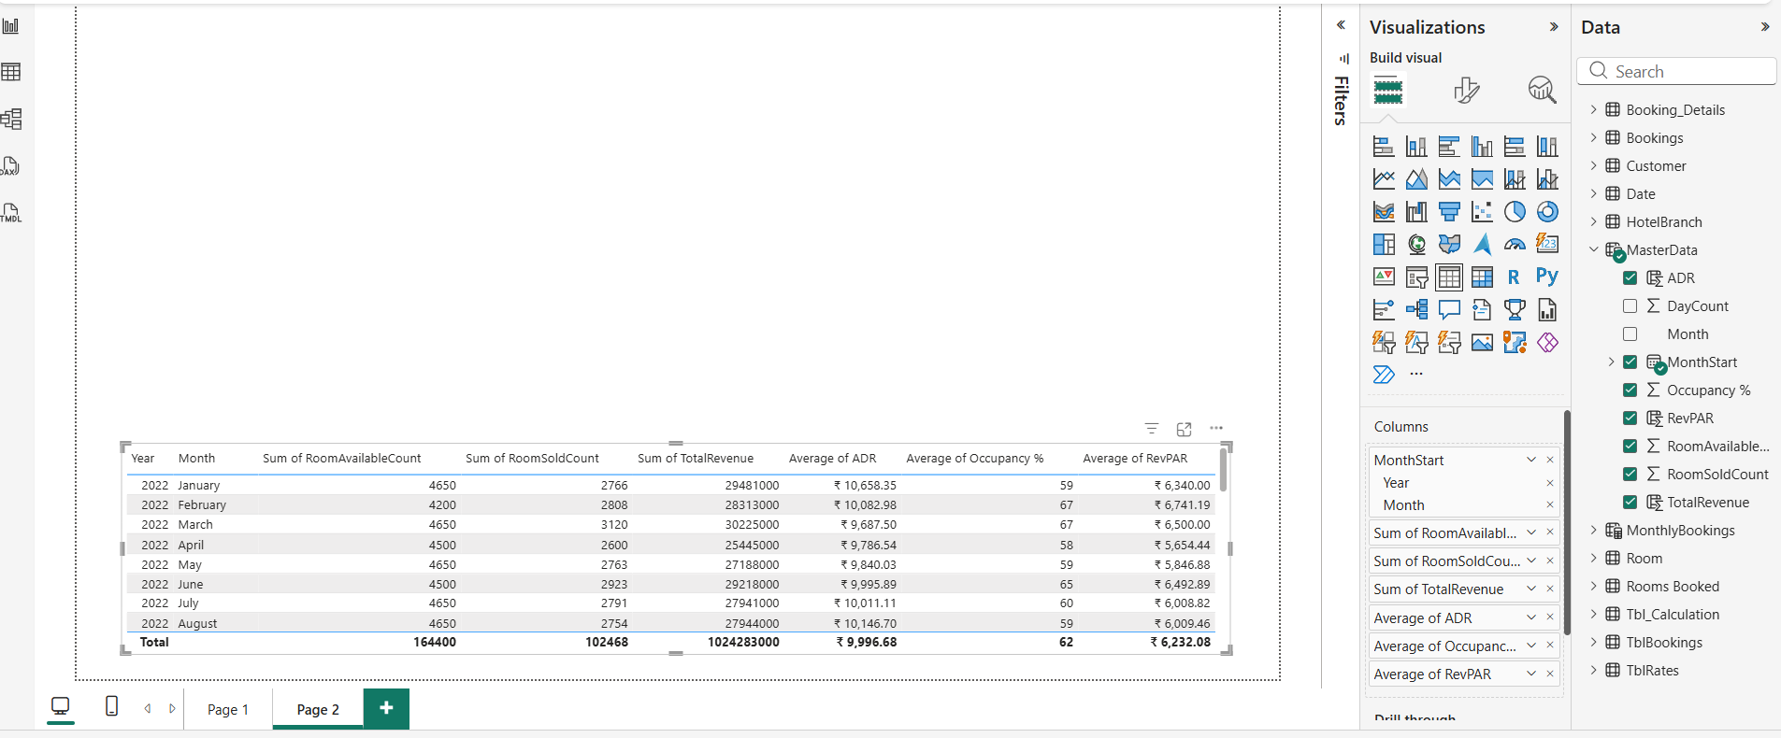RevPAR (Set to Average)

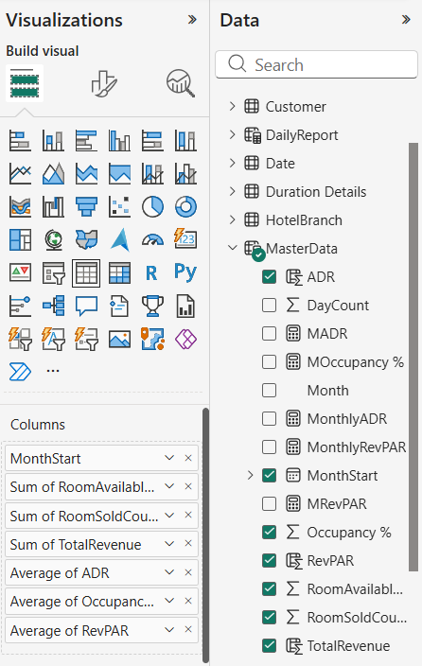

***Visual 2: Line Chart***

1. Select Visual: Click the Line Chart icon.
2. X-Axis: Drag MonthStart from the MasterData table.
3. Y-Axis: Drag the following three fields:
   * ADR (Set to Average)
   * Occupancy % (Set to Average)
4. Secondary Y-Axis: RevPAR (Set to Average)

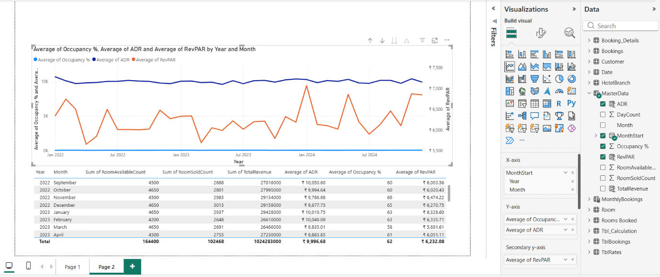

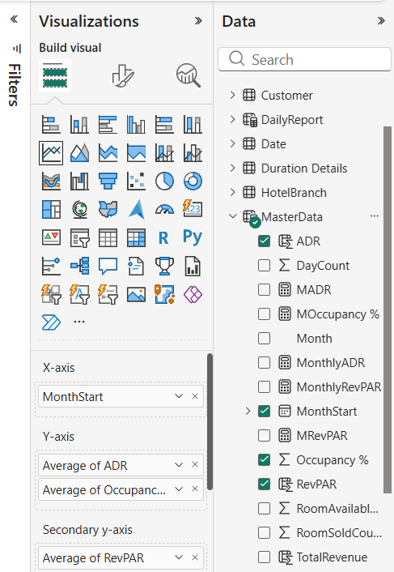

***Visual 3: KPI Cards***

1. Select Visual: Click the Card visual icon (looks like 123).
2. Card 1 (ADR):
   * Drag ADR from Tbl_Calculation (or your Measure table) to Fields.
   * Ensure aggregation is set to Average (Click dropdown arrow > Average).
   * Format: General > Title > "Average of ADR". Callout Value > Display units > Auto (shows ₹10.00K).
3. Card 2 (RevPAR):
   * Copy/Paste Card 1.
   * Replace field with RevPAR. Set aggregation to Average.
4. Card 3 (Occupancy):
   * Copy/Paste Card 1.
   * Replace field with Occupancy %. Set aggregation to Average.

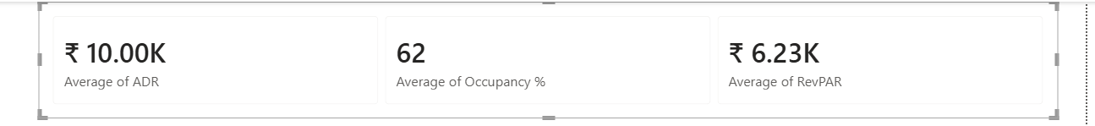

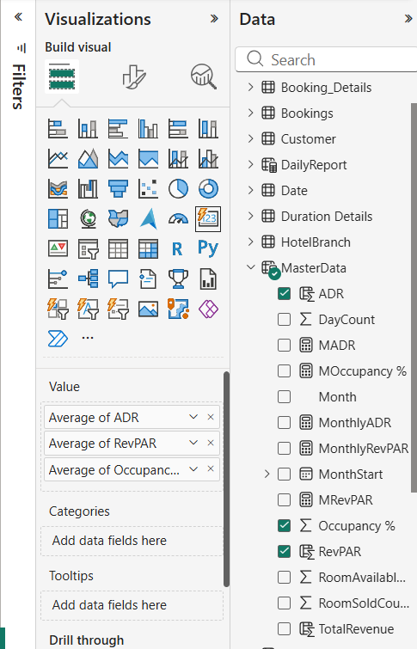

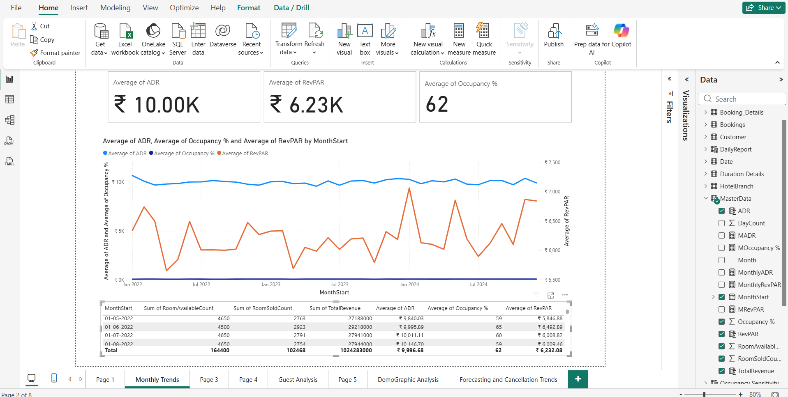

***Page 3: Time Period Analysis (Year, Week, Season)***

***Visual 4: Daily Performance***

1. Select Visual: Click the Line Chart icon.
2. X-Axis: Drag Year from MasterData.
3. Y-Axis (Left Scale):
   * Drag ADR (Set to Sum )
   * Drag RevPAR (Set to Sum).
4. Secondary Y-Axis (Right Scale):
   * Drag Occupancy % (Set to Average).
5. Go to Format (Paintbrush Icon) -> General -> Title -> Enter “Daily Performance”

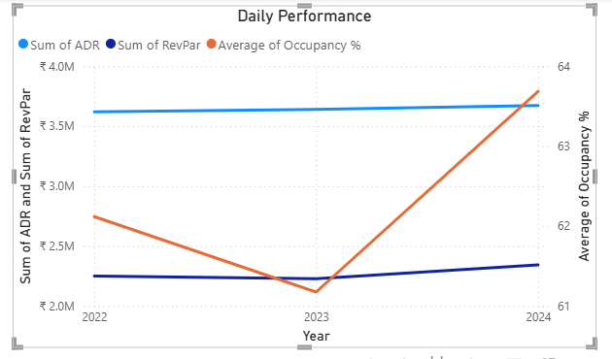

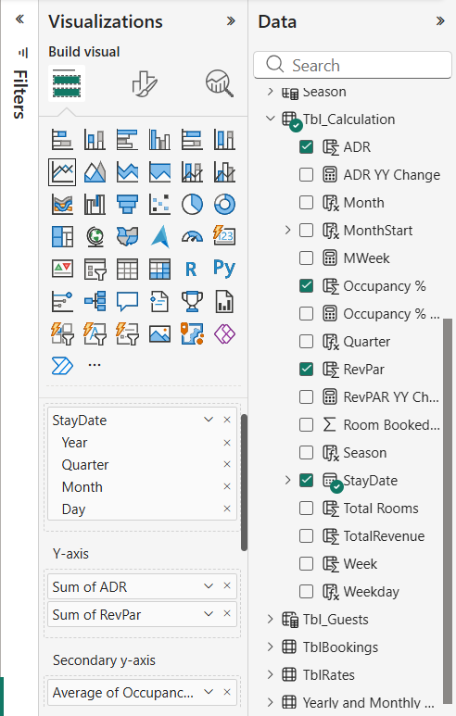

***Visual 5: Weekly Performance***

1. Select Visual: Click the Line Chart icon.
2. X-Axis: Drag Week from MasterData.
3. Y-Axis: Drag ADR (Average) and RevPAR (Sum).
4. Secondary Y-Axis: Drag Occupancy % (Average).

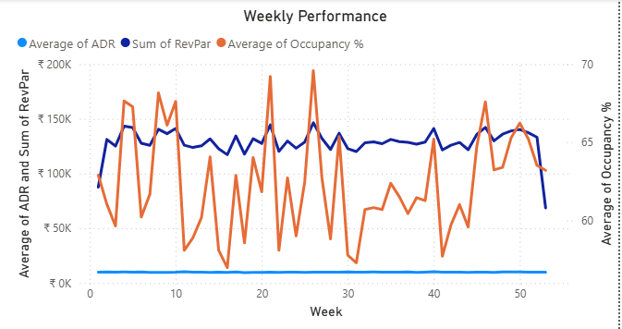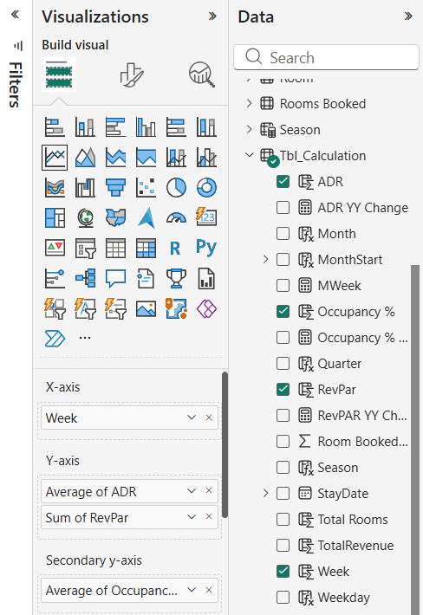

***Visual 6: Seasonal Performance***

1. Select Visual: Click the Line Chart icon.
2. X-Axis: Create a hierarchy or drag fields in this order:
   * StayDate ( Year, Quarter from Tbl_Calculation)
   * Season (from Tbl_Calculation)
3. Y-Axis: Drag ADR and RevPAR (Averages from MasterData).
4. 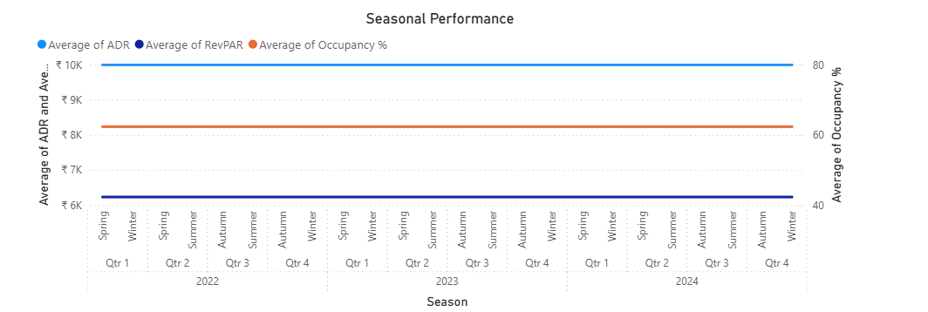Secondary Y-Axis: Drag Occupancy % from MasterData (Average).

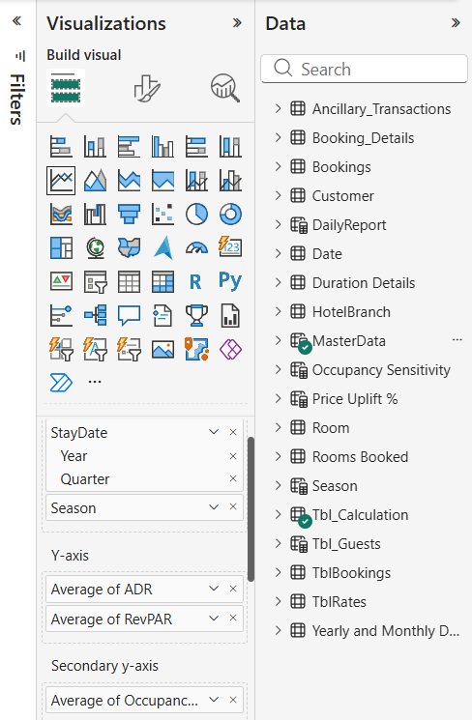

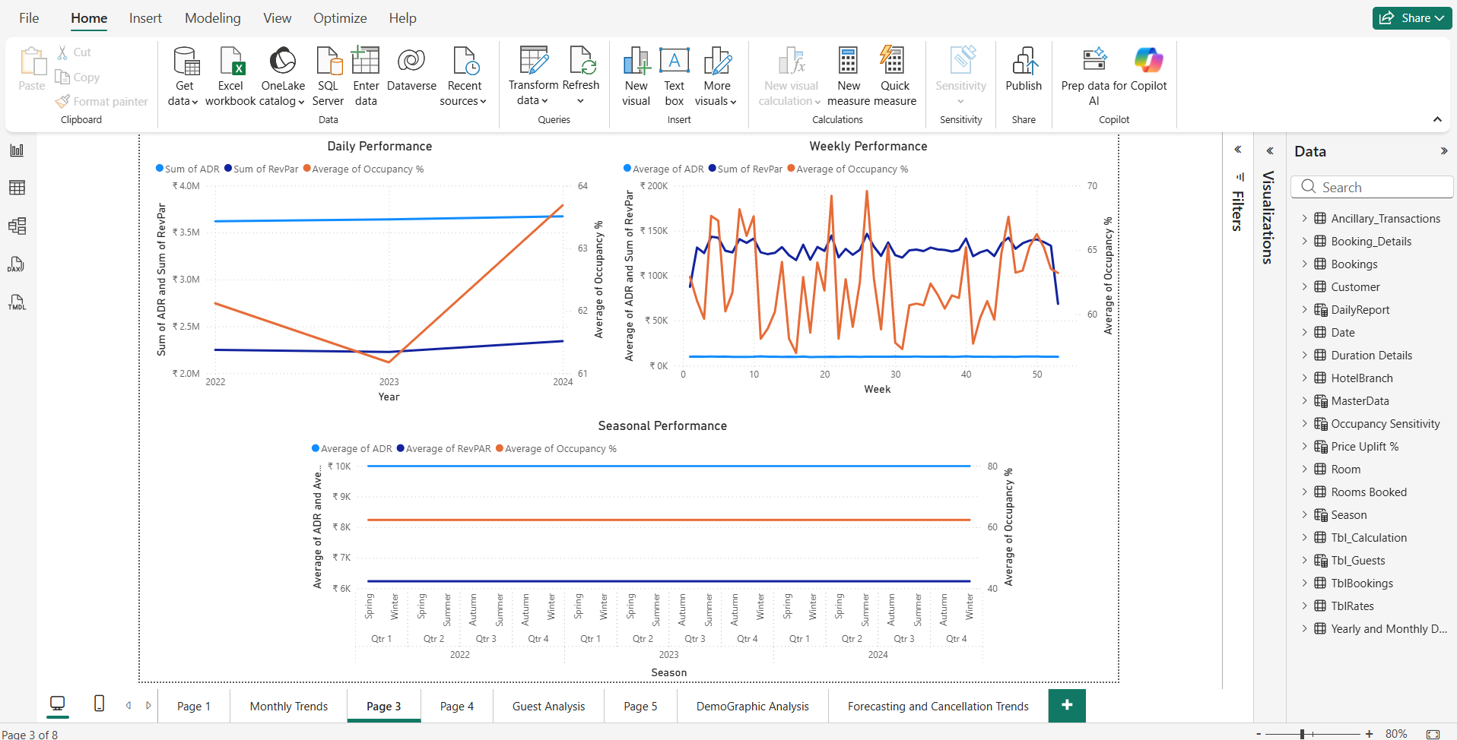

***Page 4: Drill Down Table***

***Visual 7: Table***

1. Select Visual: Click the Table icon
2. Rows (The Hierarchy): Drag field into the "Rows"
   * MonthStart from MasterData ( Year, Quarter, Month, Day)
3. Values: Drag the metrics you want to measure:
   * ADR (Select Average)
   * Occupancy % (Select Average)
   * RevPAR (Select Average)
4. Formatting:
   * 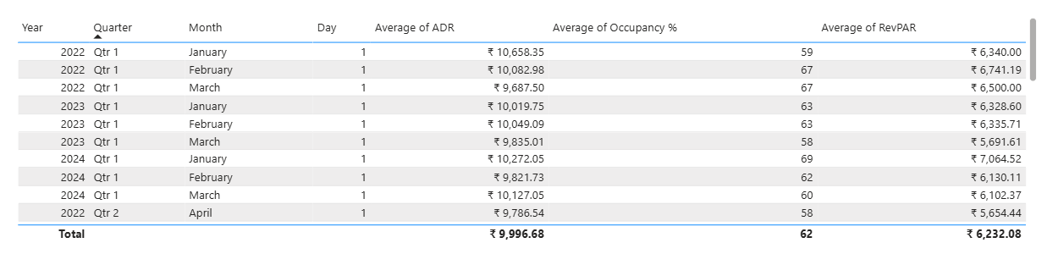Go to Specific Column formatting to apply Currency (₹) to ADR/RevPAR.

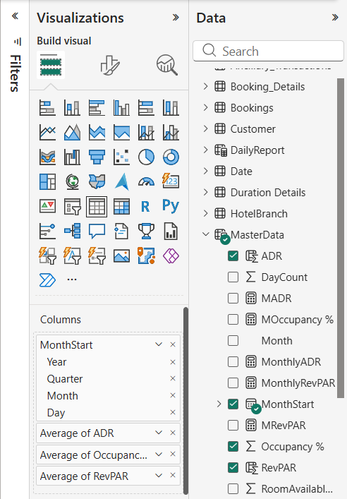

**Visual 8: Line Chart**

1. **Select Visual:** Line Chart.
2. **X-Axis:** MonthStart from MasterData ( with Year, Quarter, Month, Day).
3. 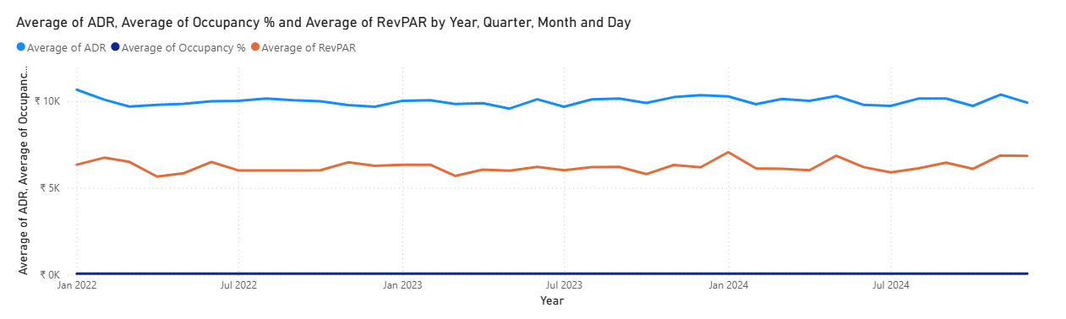**Y-Axis:** ADR (Avg), RevPAR (Avg), Occupancy % (Avg) from MasterData.

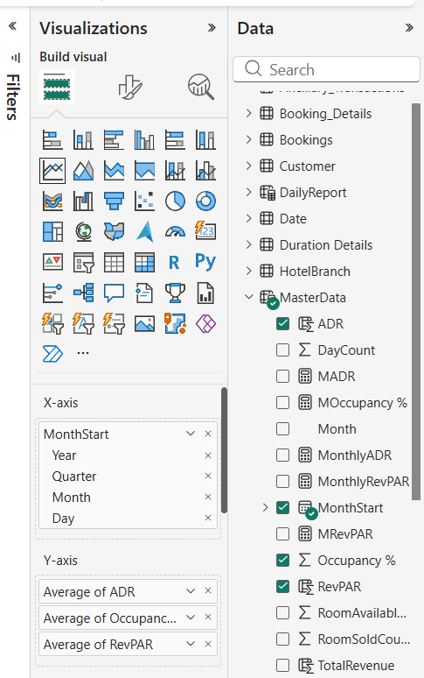

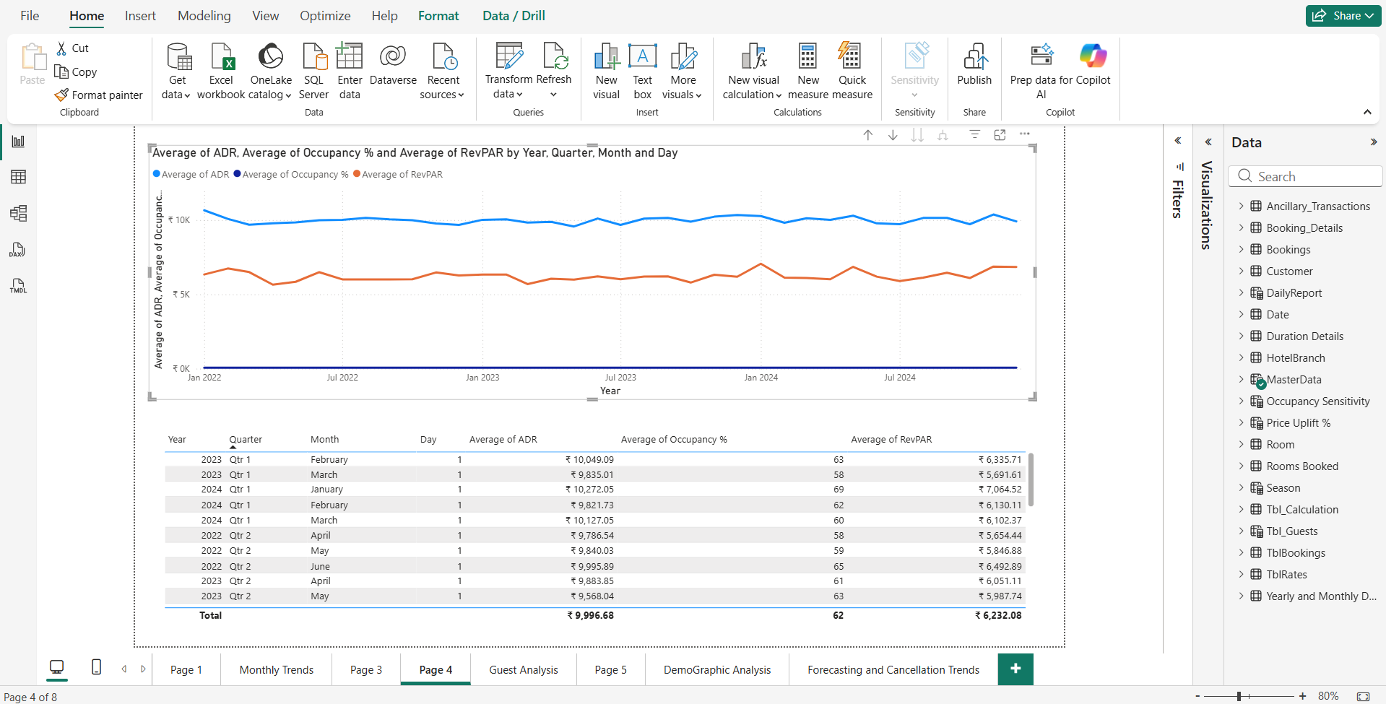**5. Insights**

**Key Performance Indicator (KPI) Analysis**

Based on the aggregated data in the KPI Cards and Summary Tables:

* Premium Market Positioning (ADR):
  + The Average Daily Rate (ADR) stands at approximately ₹10,000 (₹9,996.68).
  + Insight: This pricing structure confirms the hotel operates in the Premium/Luxury segment. The hotel commands a high price point per transaction.
* Operational Efficiency (Occupancy %):
  + The Average Occupancy Rate is 62%.
  + Insight: While the hotel charges a premium price, nearly 38% of inventory remains unsold on average.
* Revenue Reality (RevPAR):
  + The Revenue Per Available Room (RevPAR) is ₹6,232.
  + Insight: There is a distinct gap between the potential earnings (ADR: ₹10K) and actual earnings per room (RevPAR: ₹6.2K). This gap represents the "Revenue Opportunity" lost due to vacancies.

**6. Conclusion**

**Business Conclusion:**  
The data reveals a hotel chain with strong pricing power (**High ADR**) but inconsistent demand (**Moderate Occupancy**).